## List Interview Schedule

## Interview

## List Interview Result

## View Interview result

## Edit Interview result

## List question

## Add question

## Edit question

## Delete question

## Add catalog

## Edit catalog

## List catalog

## Add guideline

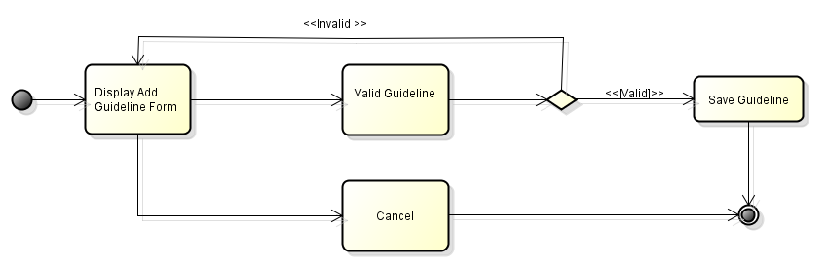

## Edit guideline

## List guideline

